|  |  |  |  |
| --- | --- | --- | --- |
| **Document Number** | **RP1** | | |
| **Document Title** | Reception Billing – Private/Public Patients | | |
| **Department Ownership** | Reception | | |
| **Document Type** | Procedure | | |
| **Department Owner** | Alysia Harper | | |
| **Document Author** | Derrick Chan | | |
| **Last Edited By** | Derrick Chan | **Lasted Edited On** | 18/06/15 |

# Purpose

To guide reception in the process of billing private and public patients for all various types of consults.

# Scope

For anyone who will carry out billing a private and public patients for any type of consult available within our organisation.

# Reference Documents

# Definitions

GP – General Practitioner

GAP – Out of pocket expense

Op Sheet – Operation sheet

Out-patient procedure – Procedure performed at Redimed

PO – Post Operation

NC – No charge

Physio - Physiotherapy

# Flowcharts (Other Images)

***To Be Determined (I will work through this with you once rest of document complete)***

# Procedures

These are the procedure options for each billable consult.

* **Consult Billing** 
  1. Billing a consult (GP, Specialist, Physio and hand therapy the same process)
  2. Billing a surgery GAP – Plastic Surgeons Only
  3. Billing an Out-patient Surgery
  4. Billing a Post Op Appointment
* **Medicare Billing**
  1. Bulk Billing
  2. Processing the Rebate when creating the invoice
  3. Sending a claim to Medicare after the account has been paid
  4. Cancelling a claim to Medicare after it has been processed
* **Physiotherapy and Hand Therapy Billing**
  1. Billable codes
  2. Billing a consult with Hicaps
  3. Process a consult with HICAPS and charging the REBATE
* **Missed Billing**

**Consult Billing**

1. **Billable Codes**

**Specialist Codes**

Initial Consult Code – **104** Subsequent Consult code - **105**

Cost - $200 Cost - $100  
Pension rate (with valid card) - $100 Pension rate (with valid card) $100  
Medicare Rebate - $72.75 Medicare Rebate - $36.55

Surgery GAP Code – **GAP**

Cost – At the surgeon’s discretion, this will be advised at the time of consult billing

Item Number – Item numbers for procedures at Redimed will be advised by the Dr

**GP Codes**

These will be advised by the GP for each consult

1. **Billing a Consult**
2. Search for the patient in Genie and find the correct consult for that day to bill

In the below e.g., this is an initial consult for Dr Adrian Brooks (plastic surgeon)

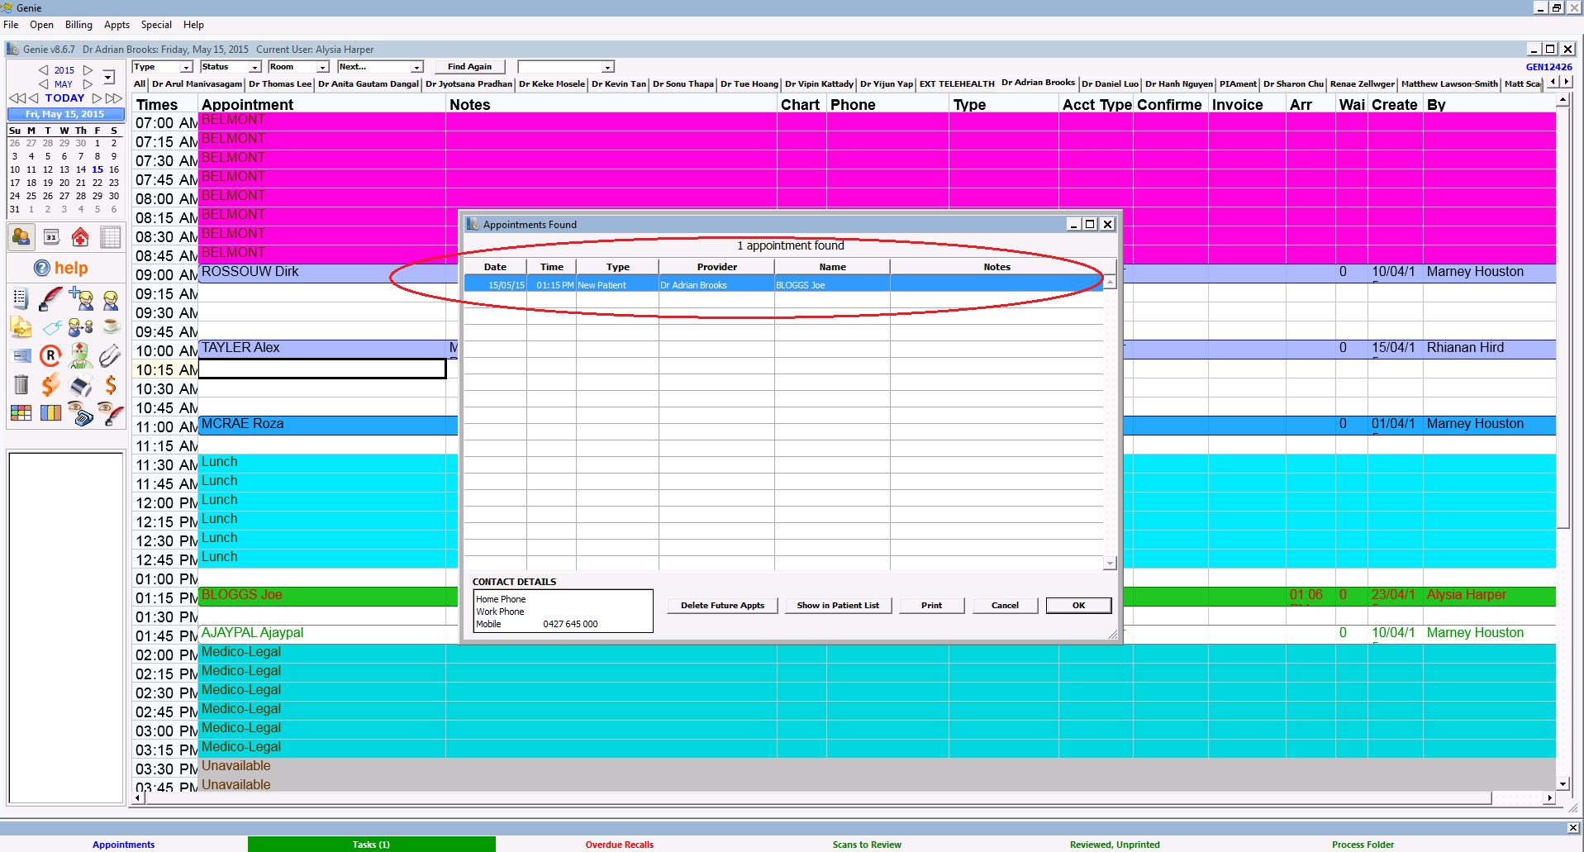

1. Once you have clicked on the correct appointment. Click the dollar sign from the icon selection on the right to bring up the billing window

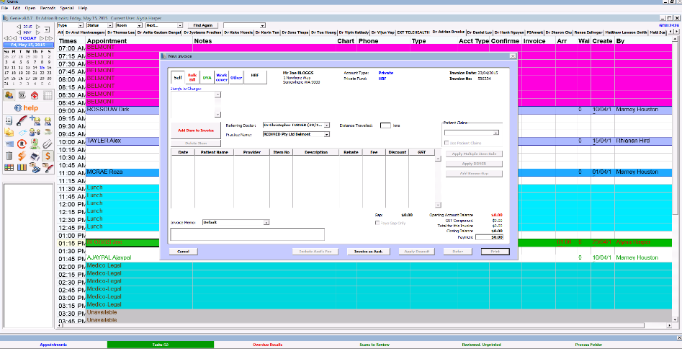

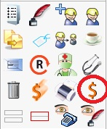

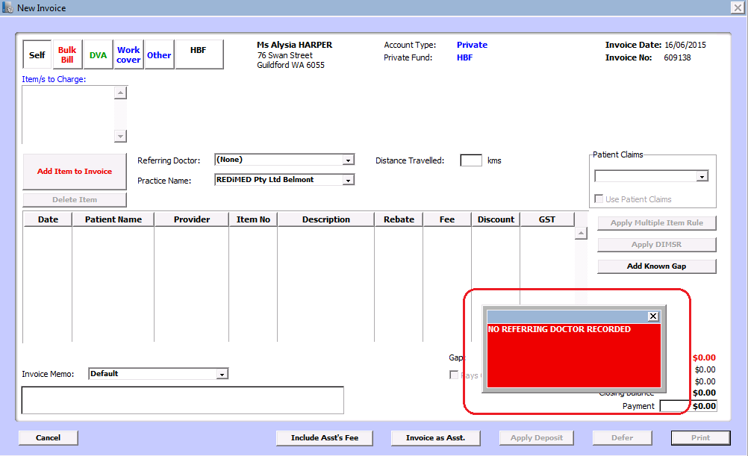PLEASE NOTE: For all specialist consults a VALID referral is required to bill the patient.

If the patient does not have a valid referral, or no referral details entered, a red box will appear ‘NO REFERRING DOCTOR RECORDED’

Please enter in a referring Dr to proceed for all specialist consults.

GP consults do not need a referral

1. Make sure the Self tab is selected.



1. Click on “Add Item to Invoice’

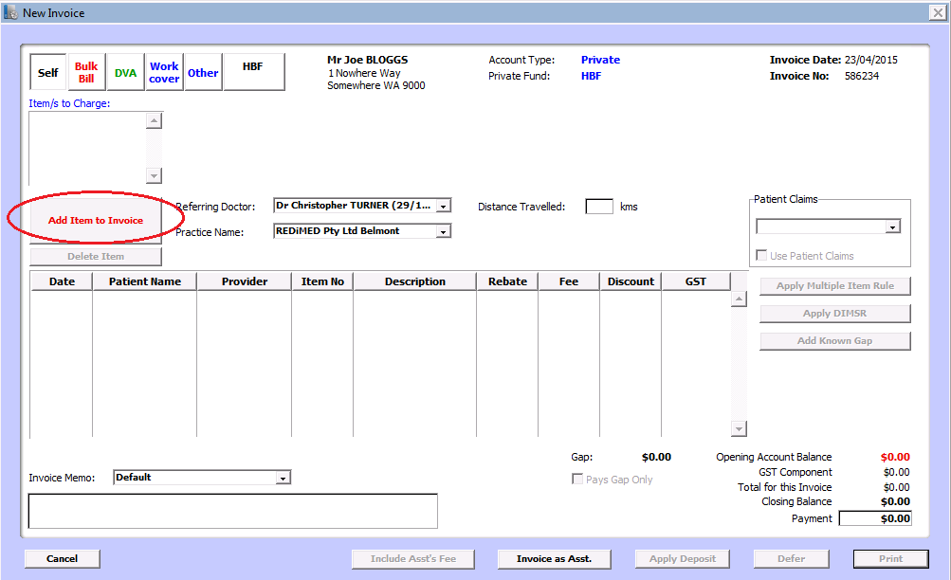

1. Enter the correct item number (in the example we are billing an initial consult – code 104 for a private patient at $200).

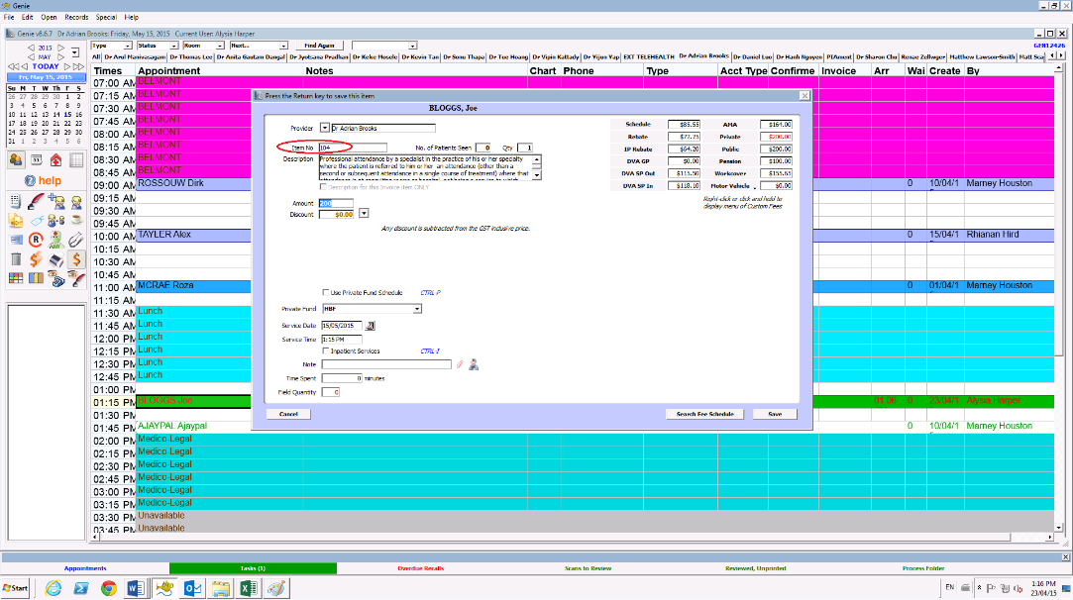

1. Click on the private tab next to the $200 Fee. When charging a private patient, we only ever use this private tab

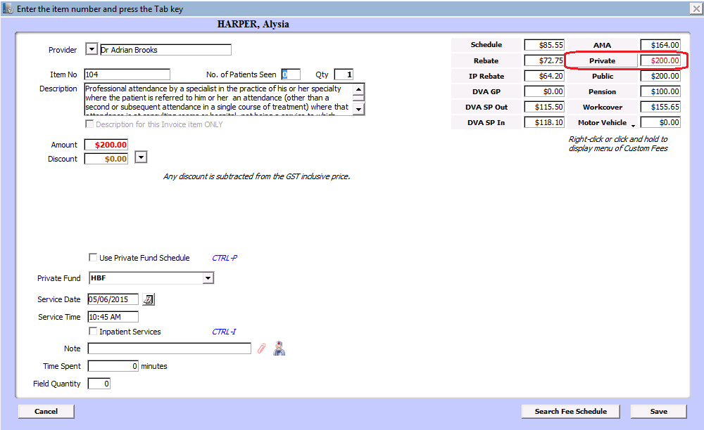

1. Click save to save this item and amount to the invoice

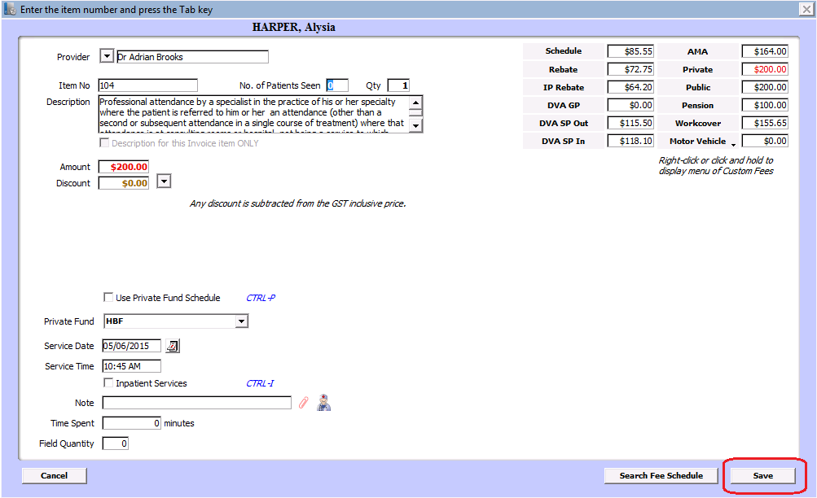

1. If there are other codes for that particular provider for that day you have repeat the process above so that they all get invoiced together.

*Please note: The items must be for the same provider and for that same day*

1. Once all relevant codes have been entered, Select the site of Service From the drop down box

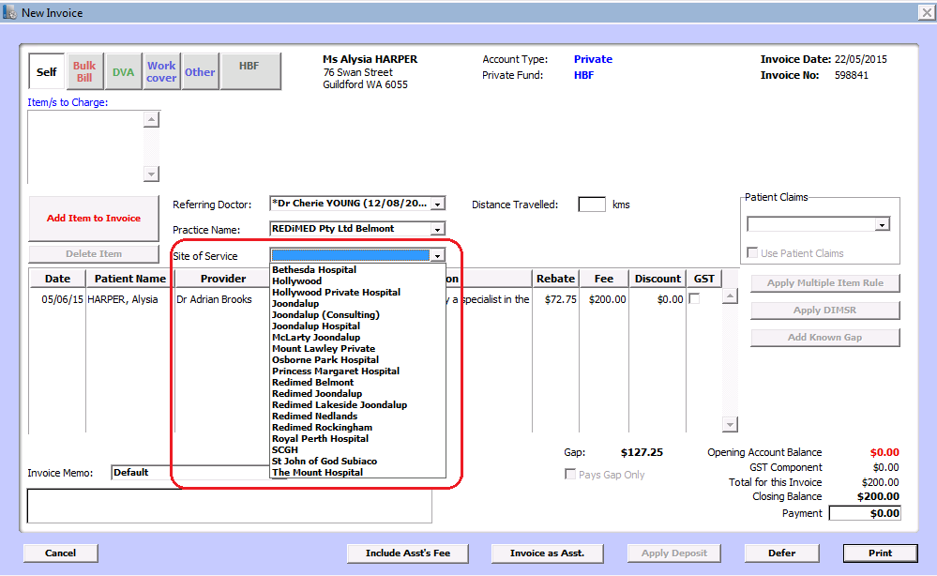

1. Select the invoice memo from the drop down box relevant to this particular invoice. In this instance it is Redimed.

**2hands** – any hand therapy appointments or codes

**Peel Health Campus** – Hospital surgeries

**Redimed** – any physio, GP or specialist consult or any other consult from a Redimed Provider (Other than hand therapy)

**RPH Transfer** – RPH Transfer patients

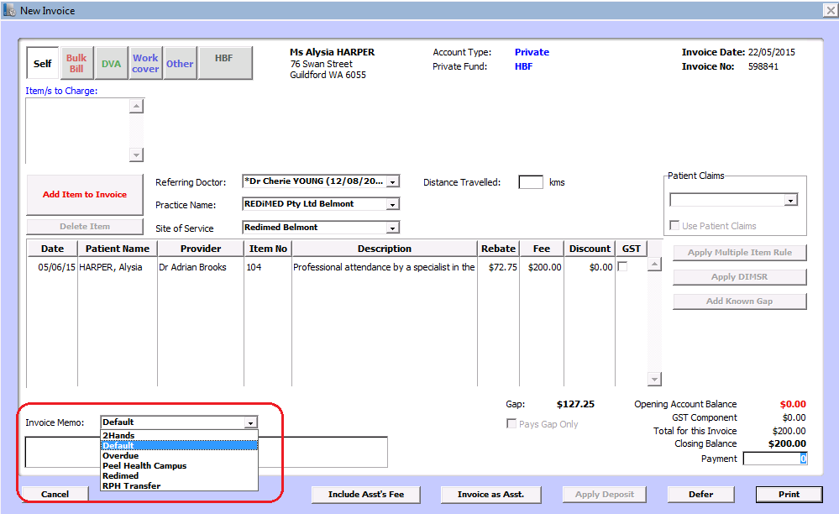

1. Enter in the payment amount in the payment section. This will be the total amount of the invoice (which is the amount the patient is paying)

In this case it is $200 for an initial consult with Dr Brooks.

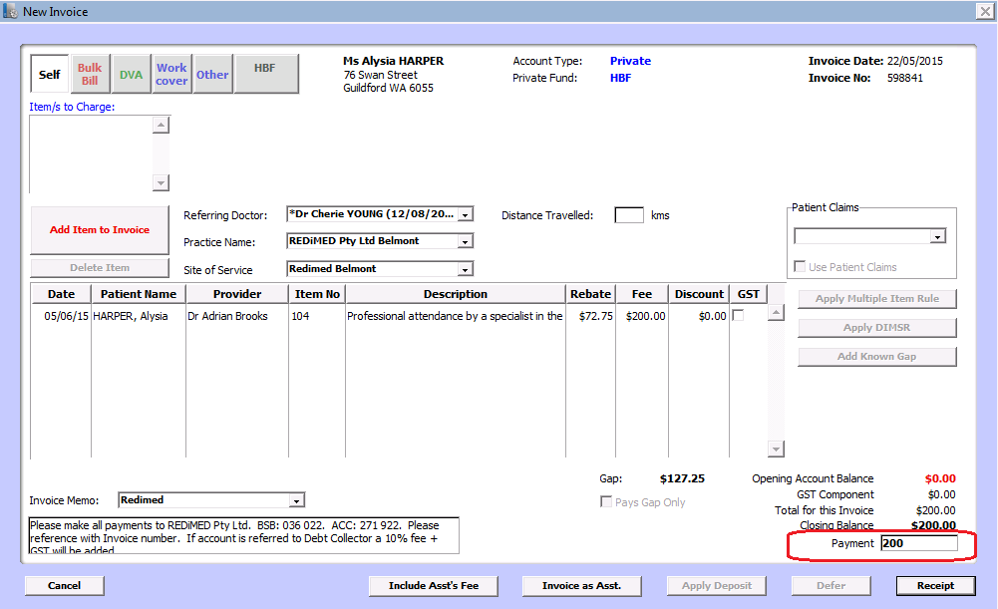

1. Click Receipt

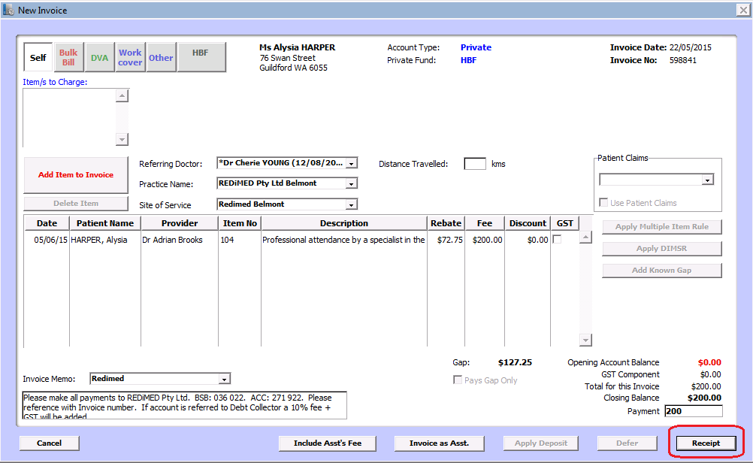

1. Select how the patient is paying for the invoice.

We only use:-

Cash – for Cash

Eftpos – for all card payments

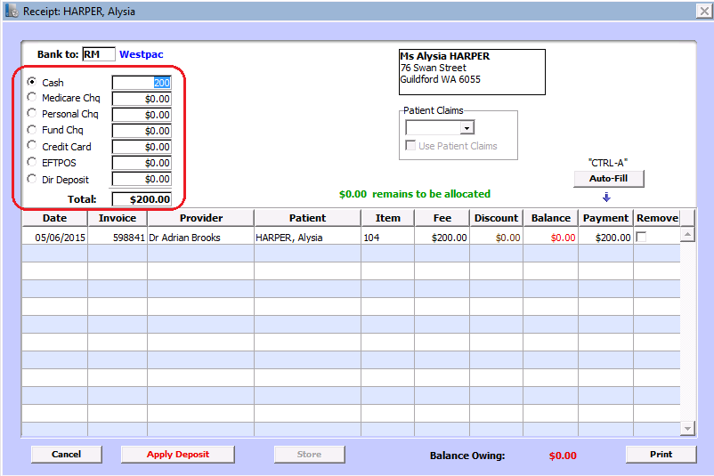

1. CASH – Take the cash from the patient and give any change from the till

EFTPOS – Process the payment through the eftpos machine (See Eftpos Procedure)

On the receipt that will print out, you need to enter the last 4 digits of the Inv/ROC # on the receipt into the box that appears once you select EFTPOS as a payment.

In this case the number you would enter in is 0821 (circled on the example receipt to the right).

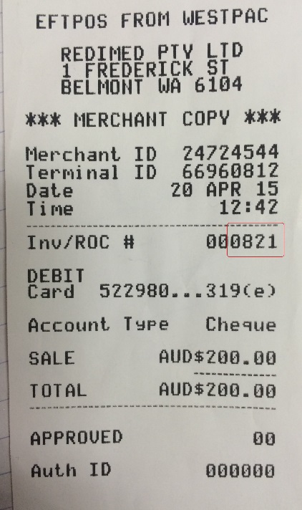

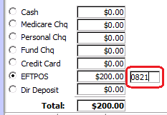

1. Click Ctrl or Autofill

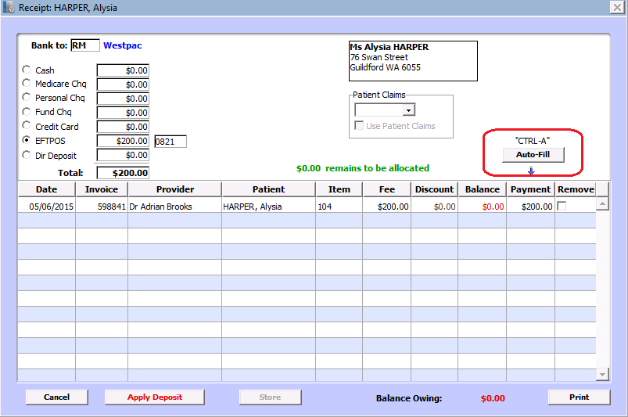

1. Click Print. This will print off the invoice you will need to give the patient

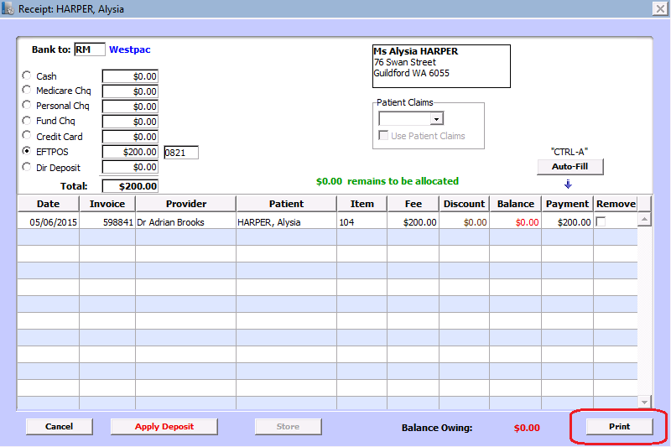

This process is the same for CASH except you take cash off the patient instead of processing an eftpos payment. And you won’t need to enter a 4 digit number.

1. **Billing a Surgery GAP – Plastic Surgeons Only**
2. 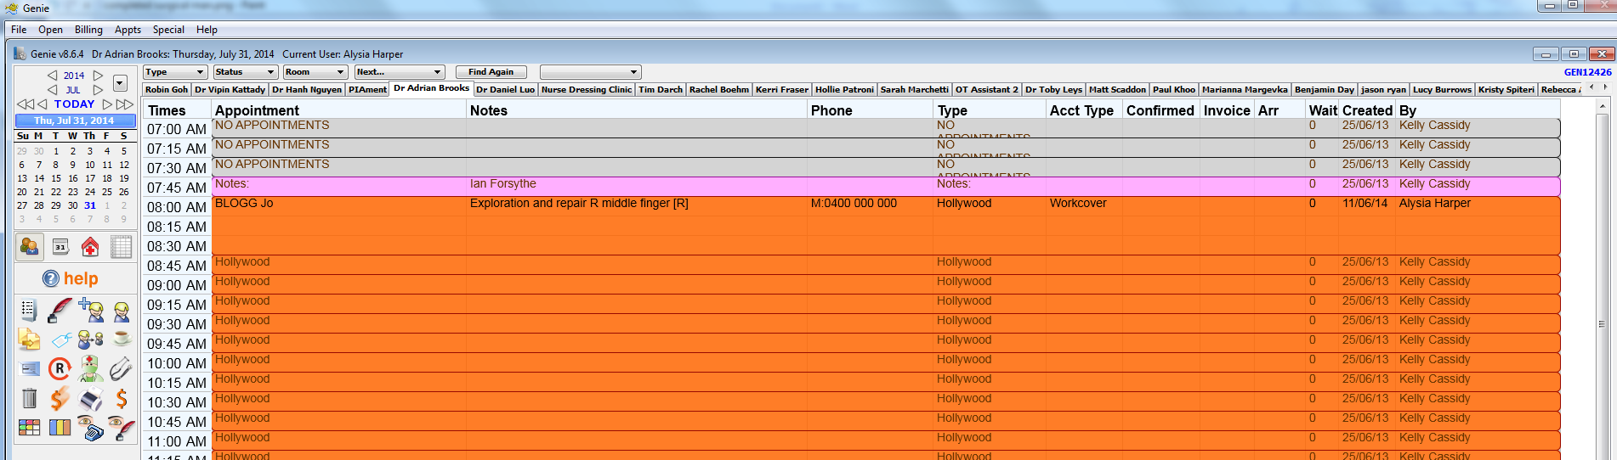Book the surgery on Genie (as per surgery booking instructions)
3. Once the surgery is booked on the scheduled date the GAP fee will get invoiced on this appointment.
4. Select the $ icon while on the patient appointment
5. Select the self tab before creating the invoice

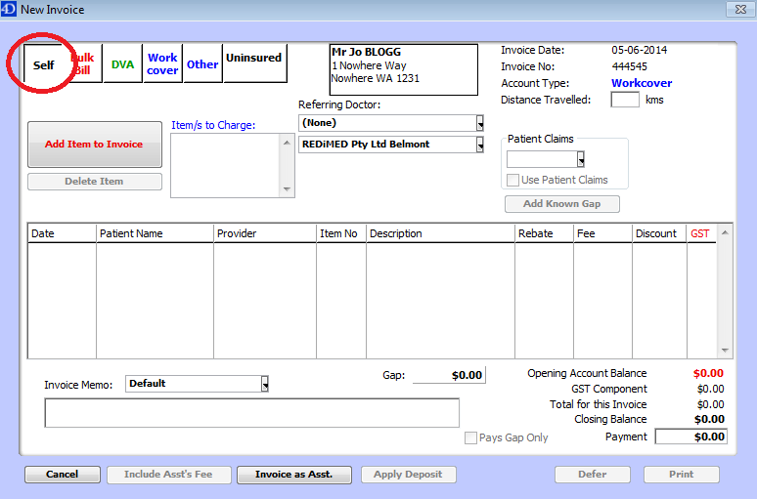

1. Click on “Add Item to Invoice’

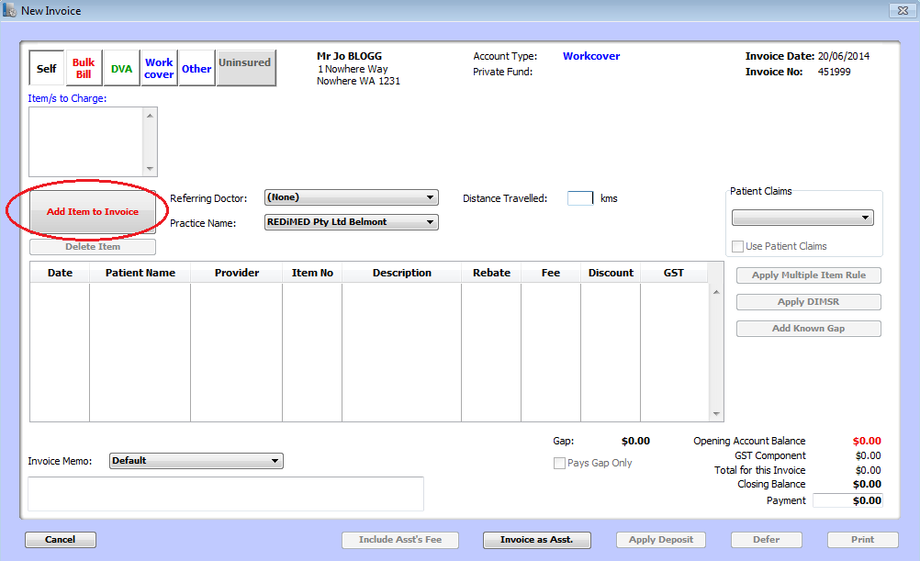

1. Enter the letters GAP into the invoice number

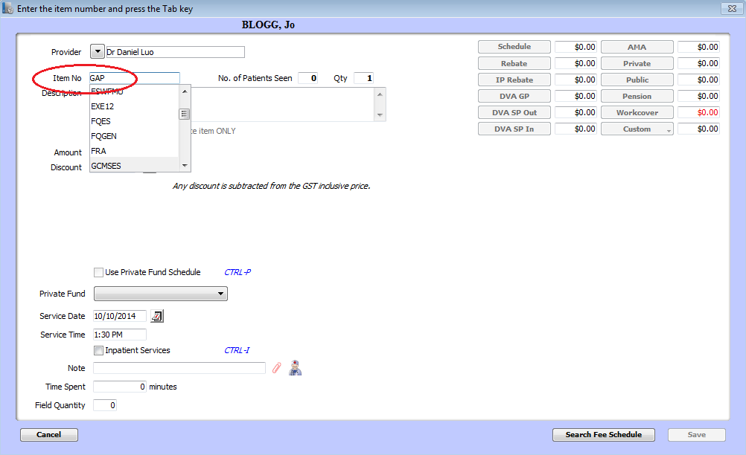

1. Enter the GAP amount into the Amount box – This amount will be advised by the

surgeon, if you are unsure of the amount, please speak with the surgeon performing

the procedure

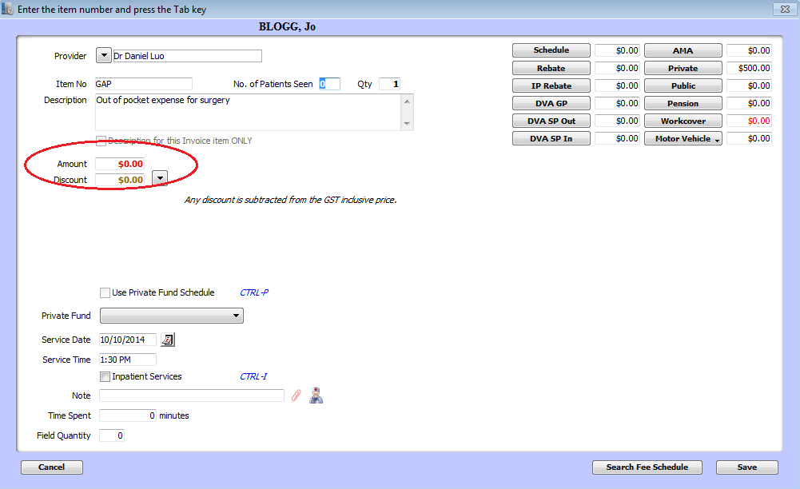

1. In this instance, the GAP amount is $500. Enter 500 into the amount box

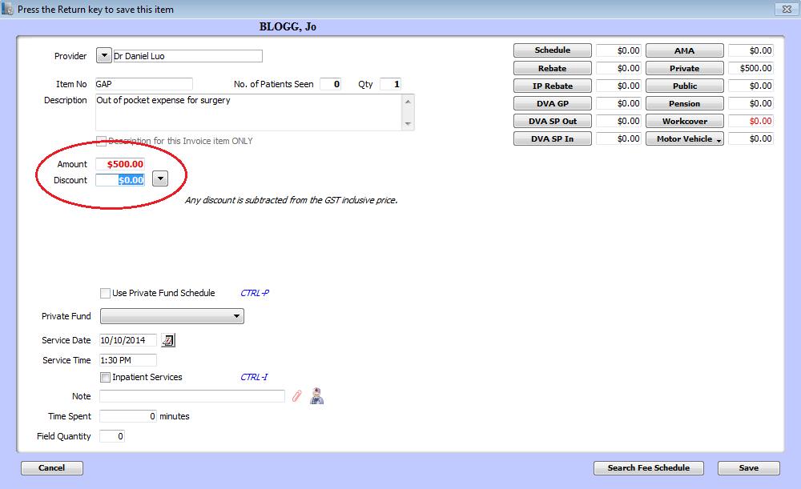

1. Click Save button, this will take you to the payment screen.
2. Select Site of Service from the drop down box – site of service is to be set where the

surgery is taking place:-

* Joondalup Health Campus
* Hollywood Private Hospital

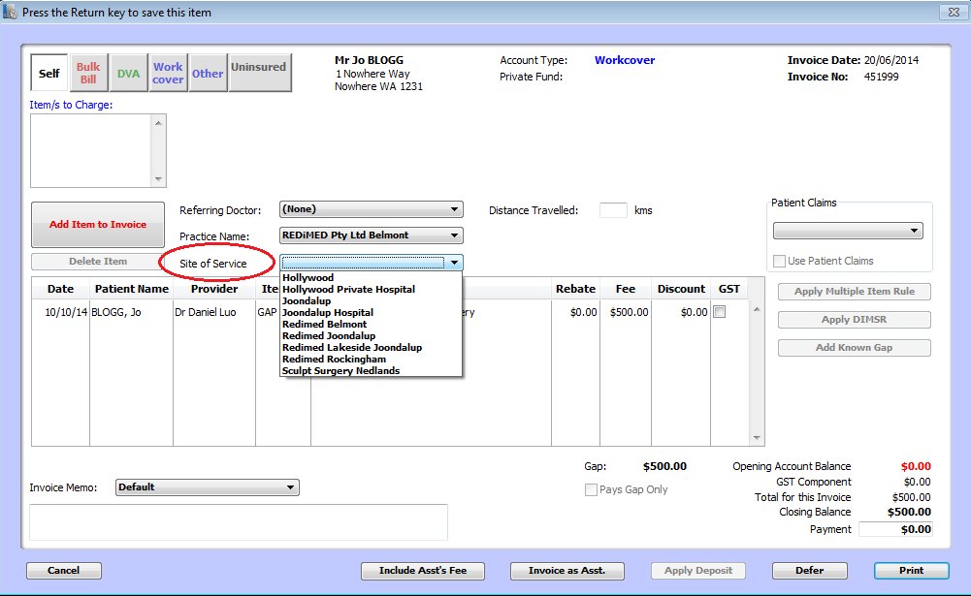

1. Select the invoice memo from drop down box (as per normal invoicing procedures)

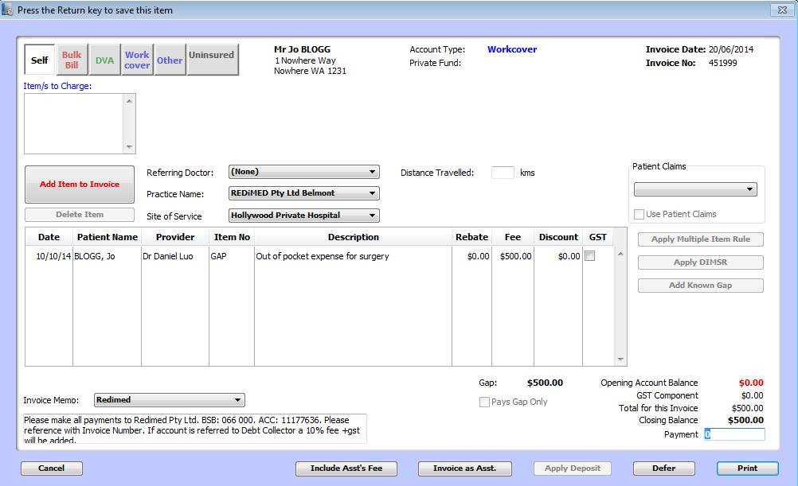

1. Proceed to taking the payment

*Note: payment is not claimable through private health or through Medicare. This is an out of pocket expense.*

1. **Billing an Out-patient Procedure**
2. The Op Sheet will be given to reception
3. The Facility fee needs to be billed (FF) – amount will be on the op sheet
4. The item numbers need to be billed (Given to reception by the surgeon on Op sheet)
5. The consult needs to be add (104 for initial or 105 for subsequent)
6. 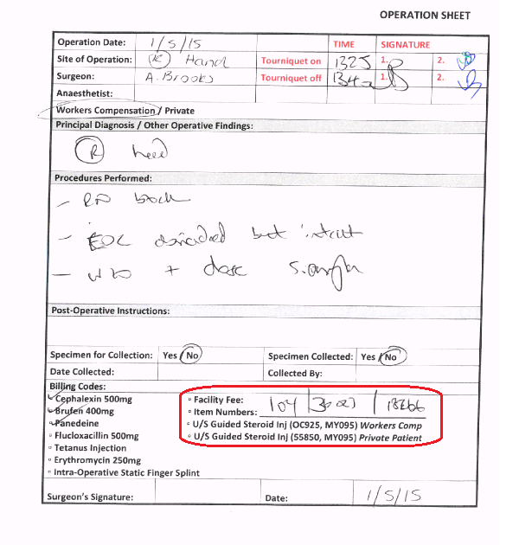The GAP payment needs to be added when applicable – as advised by the surgeon

In this instance a 104 will be billed for an initial consult, a FF of the standard $250 and the item numbers 30023 and 18266.

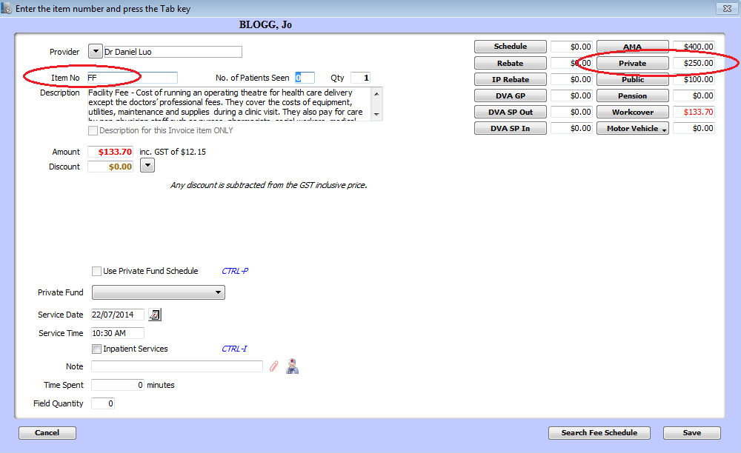**Facility Fee**

A Facility fee of $250 gets charged with all procedures in Redimed Theatre (Belmont)

1. Invoice the facility fee on the consult for that day
2. On the self tab, enter **FF** as the *facility Fee code*. This cost should be $250 standard fee for private patients – unless otherwise specified by the surgeon.
3. Click Save and Enter in the GAP code
4. Click Save and Enter in the consult code
5. Click Save and Enter in the Item Numbers – in this case 30023 and 18266

Surgical Item numbers must always be invoiced at the rebate price

1. 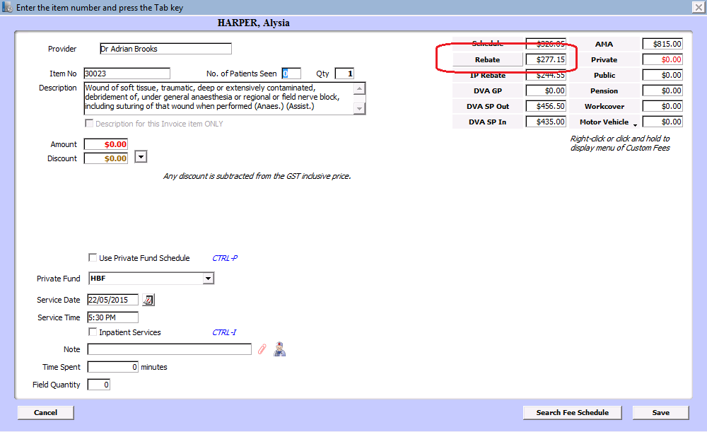Click the Rebate box
2. 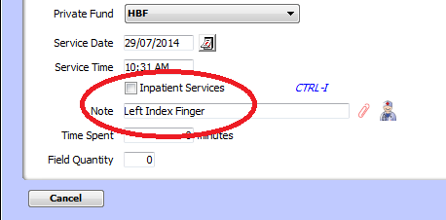Surgical items must always have the location of injury typed in the notes box & the inpatient box must NEVER be ticked.
3. If there is more than 1 surgical item number, the description for each item number must look like below:

|  |  |
| --- | --- |
| 30023 – $277.15 Left Index Finger **OR**  30023 – $277.15 Left Middle Finger  30023 – $277.15 Left Ring Finger | 30023 – $277.15 Left Index Finger  47963 – $184.05 Left Index Finger  39330 – $276.80 Left Index Finger |

1. The button must ALWAYS be click if you’re billing more than 1 item number. This automatically calculates item numbers from 100% 50% 25% (the highest amount being 100% lowest amount being 25%) for example:

|  |  |
| --- | --- |
| 30023 - $277.15 (100%) **OR**  30023 - $138.60 (50%)  30023 - $69.30 (25%) | 30023 - $277.15 (100%)  47963 - $46.05 (25%)  39330 - $138.40 (50%) |

1. Change the site of service



1. If the patient wants you to process their Medicare refund online you must fill out patient claims – this will only work if the patient has their bank details linked.

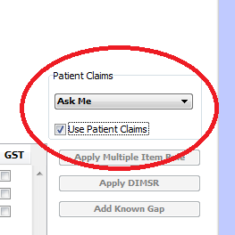

1. If not, the patient can take their receipt to Medicare and claim themselves
2. **Billing a post op appointment**
3. Patients who are in their post op stage must be invoiced with the item **PO** at $0.00 every time they see the doctor, please see below:

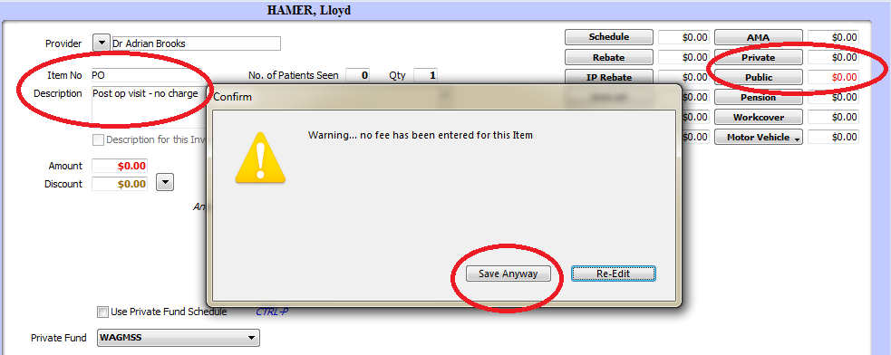

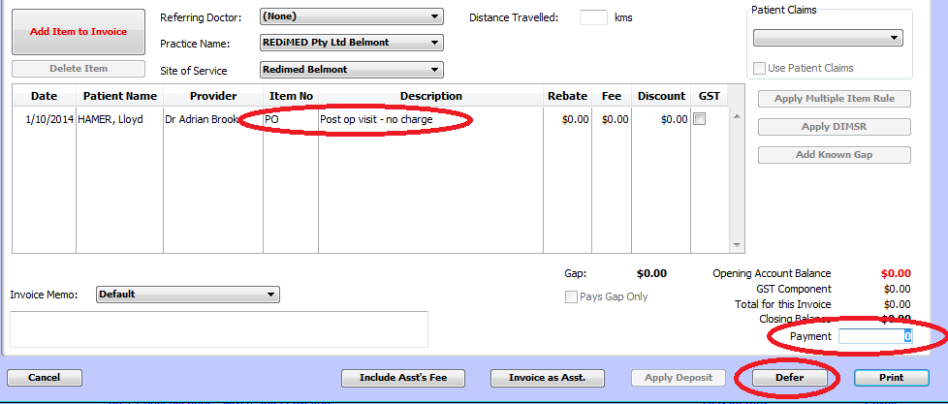

1. If the doctor has said no charge & the patient cannot be “Bulk Billed” due to not having a valid Medicare number or valid referral. You must invoice them with item NC at $0.00, please see below:

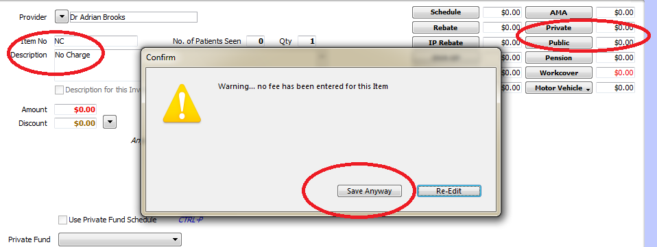

1. 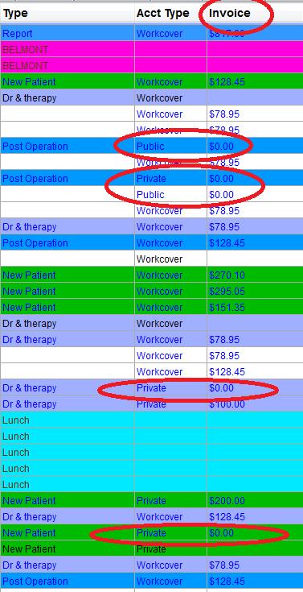At the end of every clinic, the doctors list of patients should all be highlighted blue. The patients you have invoiced with items NC or PO will have $0.00 in the invoice column, see below:

**Medicare Billing**

1. **Bulk Billing**

Private patients can claim a rebate from any Doctor that is registered with Medicare

For Medicare rebates on specialist appointments the patient must have a valid referral

Bulk billing isn’t valid for Allied Health appointments

**Bulk Billing**

**When bulk billing the patient does not pay anything out of their own pocket. The rebate amount is claimed from Medicare directly through their Medicare number online.**

**It is at the Drs discretion if the patient is to be bulk billed or not.**

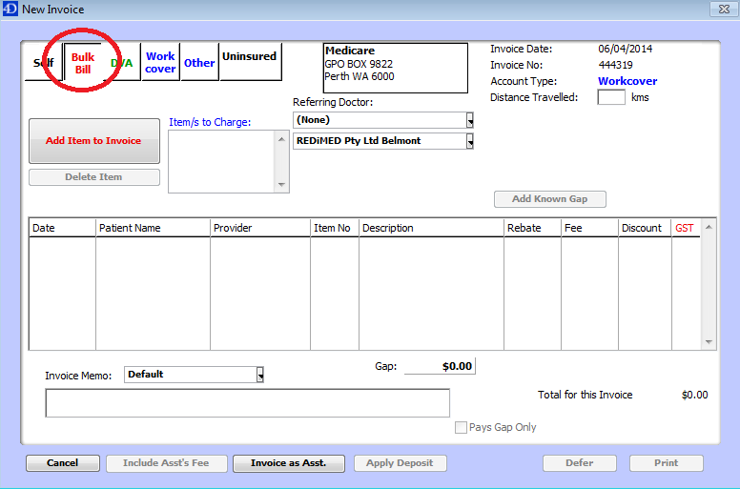

1. When creating the invoice select the ***Bulk Bill tab instead of Self*** at the top of the invoice screen

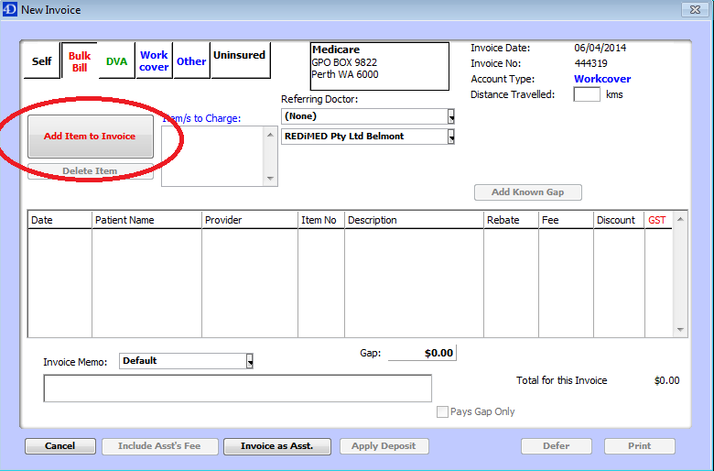

1. Select Add Item to Invoice (this will bring up another screen to enter the item number)
2. 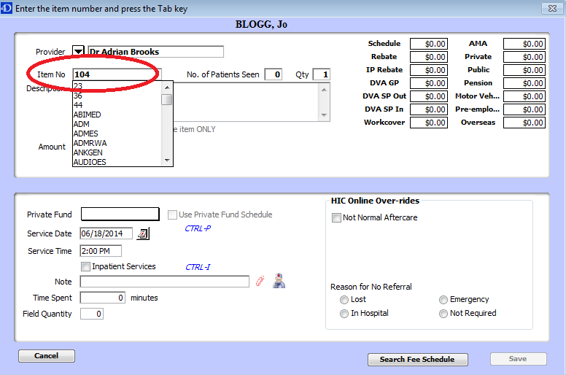Enter the ***item number*** into the box provided and push the ***Tab*** key (this will enter all available prices into the corresponding boxes.
3. 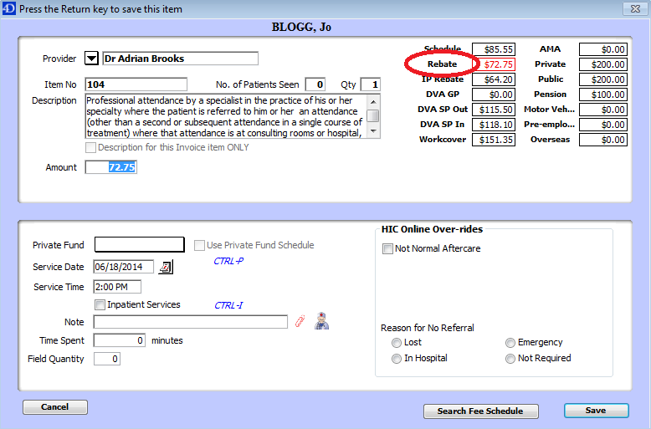Select the ***Rebate*** box (this is the rebate price that will be collected from Medicare. The patient is not out of pocket anything when being bulk billed)
4. Click Save (Bottom right hand corner)
5. 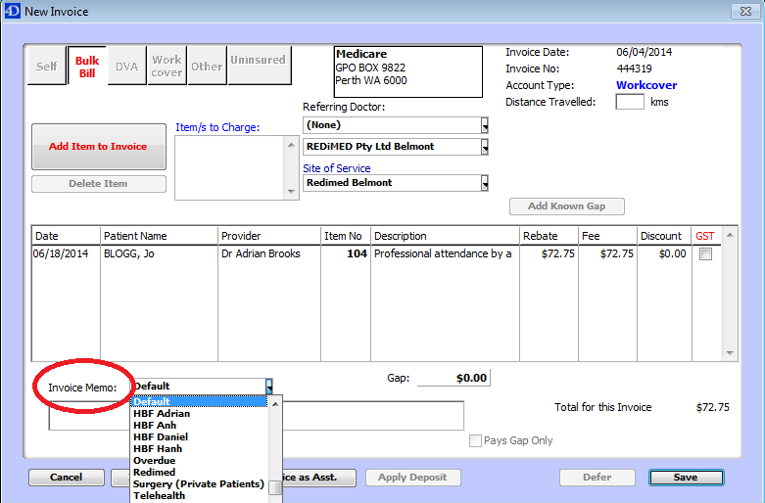Invoice Memo gets changed to the correct department (as per normal invoicing procedure)
6. Click ***Save*** (bottom right hand corner)
7. This will print out a statement of claim form instead of a standard invoice. This is confirmation that the payment will be received by Medicare and the patient has been bulk billed.

Genie will not allow for bulk billing when;

* The incorrect referral details have been entered into Genie before beginning the bulk billing process
* The referral has expired (for specialist appointments)
* The Medicare details are incorrect

1. **Claiming the rebate for the patient**

* This process means the patient will not have to take their invoice to Medicare and claim the rebate themselves.
* The rebate will take anywhere for 24 – 72 hours to go in the patients nominated bank account
* If the patient does not have their bank details registered with Medicare, they will be sent out a cheque from Medicare.
* Claiming this can be done while creating the invoice, or after the invoice has already been paid
* This claim can also be cancelled if processed and the patient decides they would rather go themselves to collect this directly from Medicare.

**Processing the rebate while creating the invoice**

**The patient pays the full fee and they will receive the rebate back from Medicare**

1. **Select self-tab**
2. 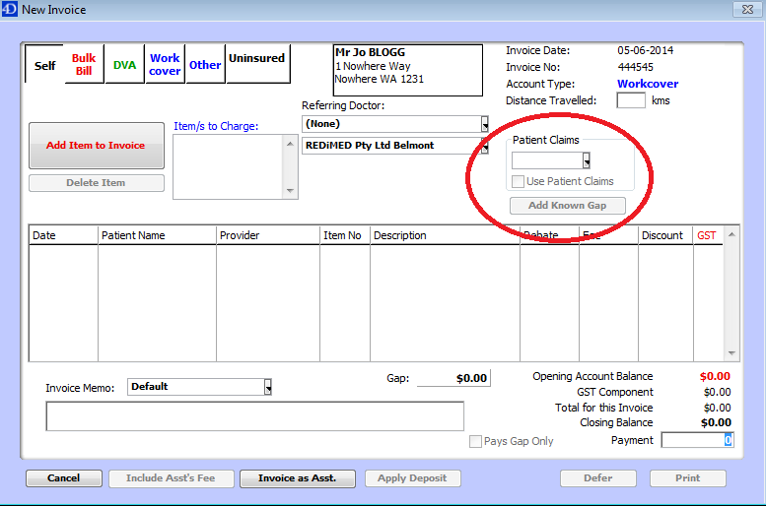Go to the drop box under **Patient Claims**
3. Select from the drop box
   1. ***Ask me*** – every time the patient attends our clinic they will get asked if they would like us to claim back for them
   2. ***Always*** – Every time the patient attends Redimed, we will process the claim on their behalf and Genie will do this for every invoice. (MEMO: this will try process for all invoices, so for any non-Medicare claimable payments you need to unselect the Use patient claims box)
   3. ***Never*** – The patient never wants us to process the claim for them and are happy to take their receipt to Medicare themselves to claim their rebate

Note: when selecting a function from this drop box, this saves for each invoice.

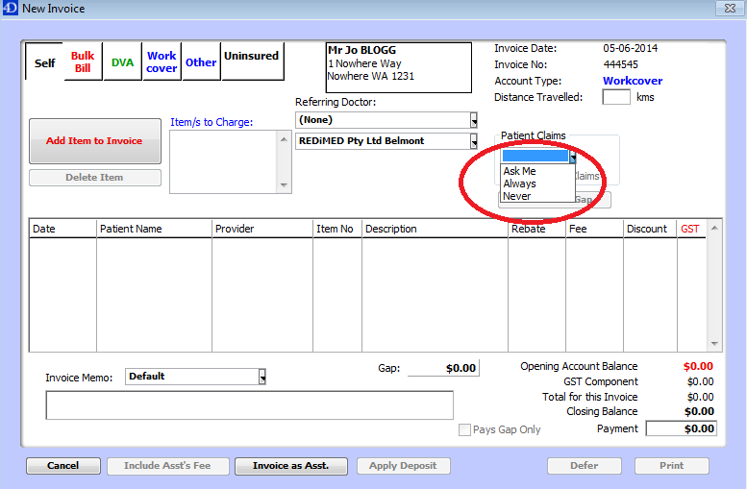

1. Something must be selected from the drop box before you can tick the Use patient claims box. If you select;
   1. ***Ask me*** - the use patient claims box will need to be ticked manually each time a patient is invoiced
   2. ***Always*** – this will automatically tick the use patient claims box each time the patient is invoiced
   3. ***Never*** – this will never tick the use patient claims box for the patient
2. Add Item to Invoice

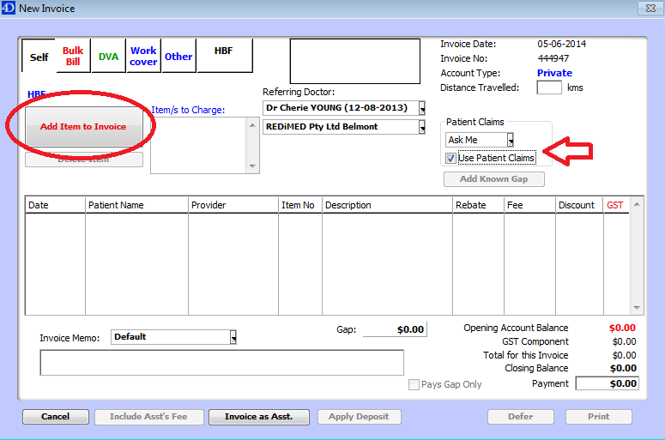

1. Enter the item number to the invoice, which will then proceed to the payment screen
2. Once the payment is processed a box will appear with the patient and Medicare details (this information does not get changed) Click OK
3. The claim will proceed to Medicare.:
4. If this processes correctly the windows will close and a Statement of Claim invoice will print
5. If there are any errors with the claim a pop up box will appear and this will need to be amended before this is processed
6. **Processing the rebate after the invoice is complete**

Processing the claim to Medicare after invoice has been paid and receipted off

1. ***Ctrl F*** to the patients appointment
2. 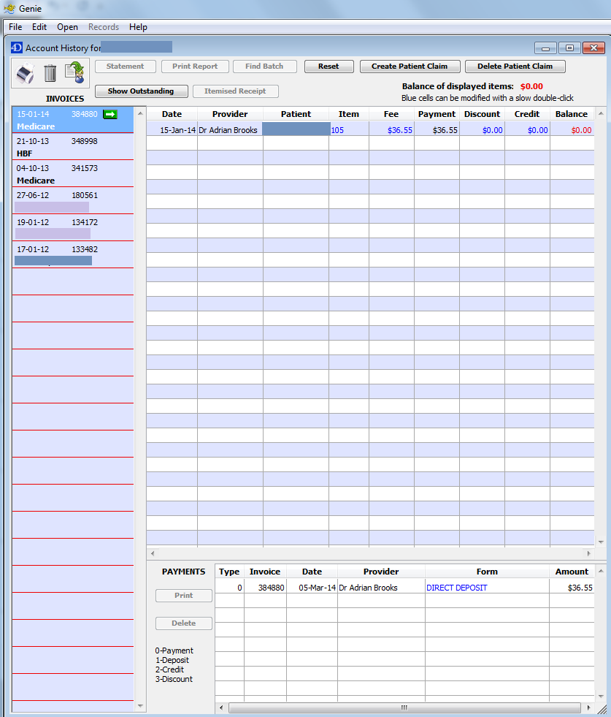When on patients appointment, ***Ctrl H*** to bring up history of accounts
3. 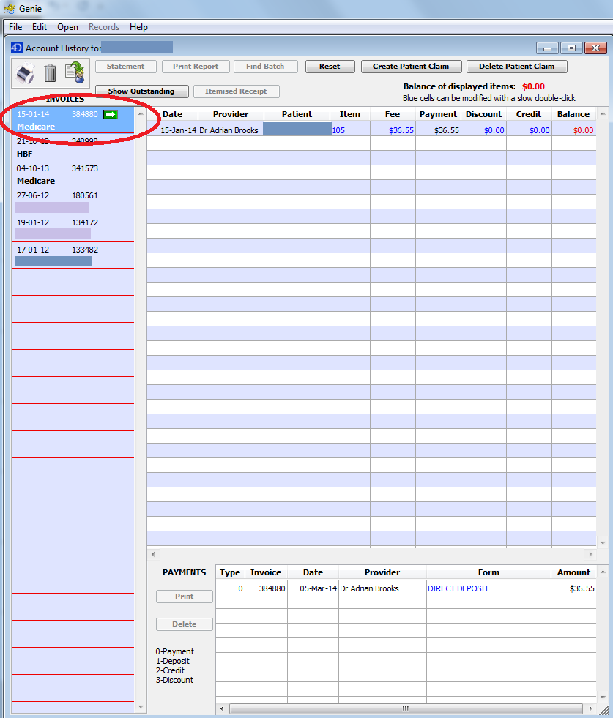Highlight on the left side which account you would like to send to Medicare
4. 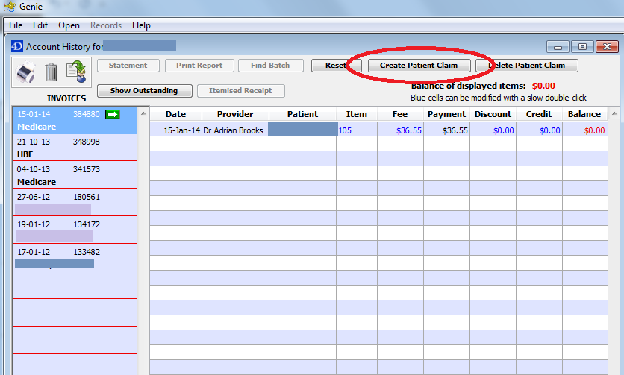Select ***Create Patient Claim*** while highlighted on this account

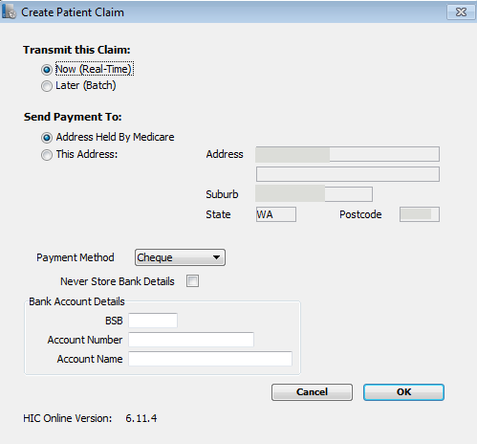

1. The Create patient claim box will appear



1. Click ***OK***
2. If the claim doesn’t process, an error will appear. If it proceeds to the printing of the invoice, the claim has been sent successfully to Medicare.
3. **Cancelling the rebate after it has been sent to Medicare**

This cannot be processed if Medicare has already finalized the claim and sent the payment

1. ***Ctrl F*** to the patients appointment
2. When on patients appointment, ***Ctrl H*** to bring up history of accounts
3. Highlight on the left side which account you would like to send to Medicare
4. 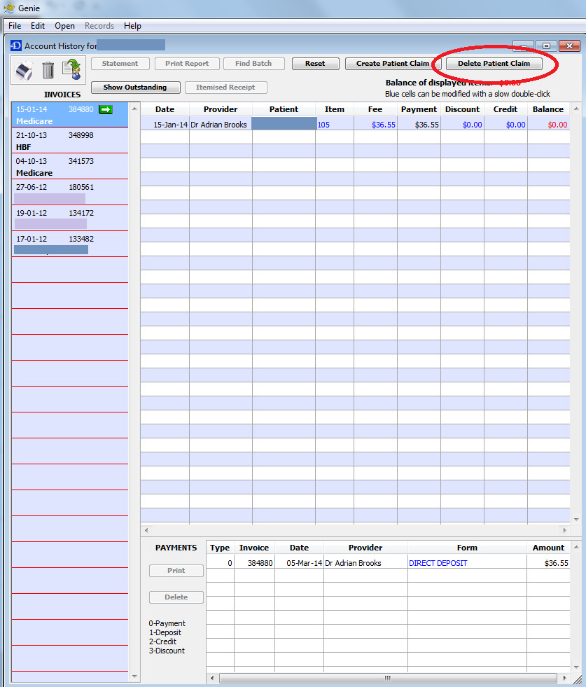Select ***Delete Patient Claim*** while highlighted on this account
5. If this cannot be cancelled an error will appear and this will not successfully be cancelled.

**Physiotherapy and Hand Therapy Billing**

1. **Billable Codes**

**Physiotherapy**

Initial Consult – T500  
Subsequent Consult – T505

Consumables – The physio may have extra codes for consumables that need to be billed, these will be advised at the time of Billing.

**Hand Therapy**

Initial Consult – a1  
Subsequent Consult – a4

Consumables – The hand therapist may have extra codes for consumables that need to be billed, these will be advised at the time of Billing.

Please note – all Hand therapy codes require an “a” to be put in front of the number when entering into Genie.

1. **Processing a Payment Using HICAPS**
2. Go to the physio/hand therapy appointment on Genie
3. 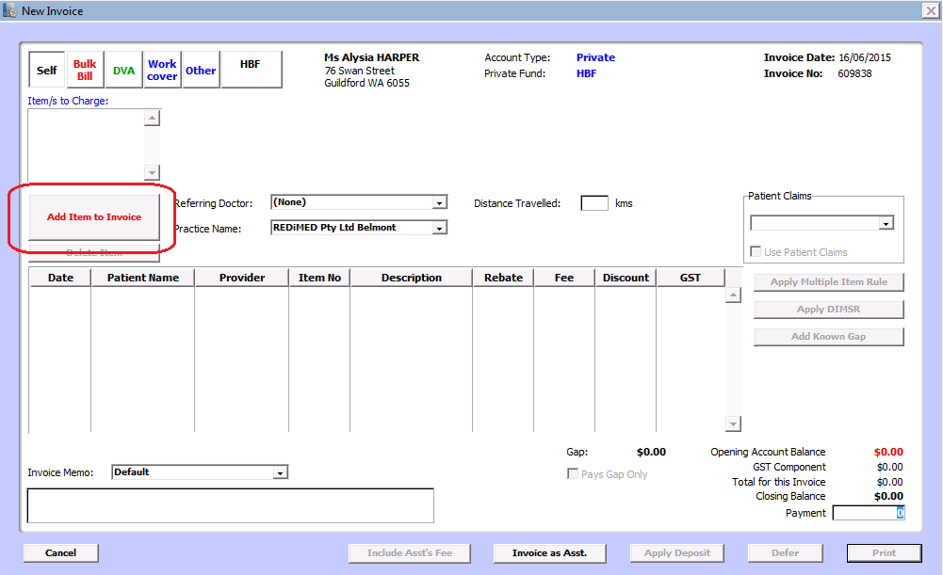while that appointment is selected, click on the dollar sign to invoice the consult
4. Click ‘Add Item to Invoice’
5. 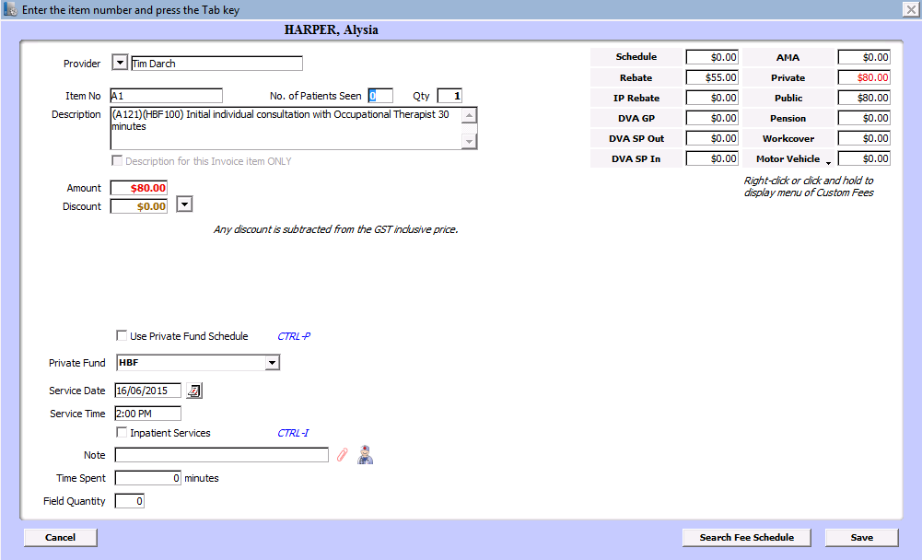Enter in the consult code – In this instance we are invoicing an initial consult for a hand therapy consult – a1 at $80.00
6. 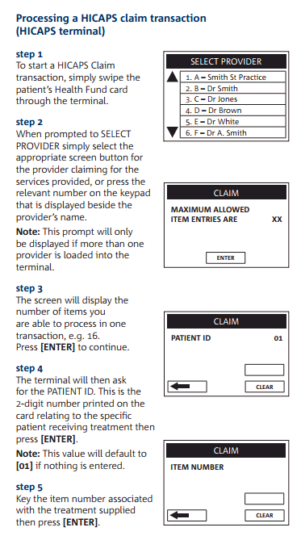Now Swipe the patients’ health fund card in the HICAPS machine and follow the process

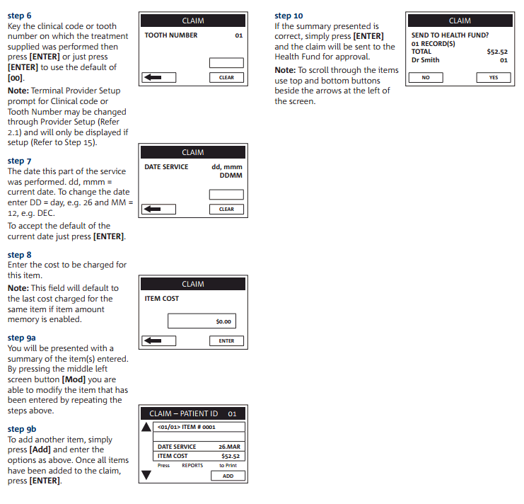

1. 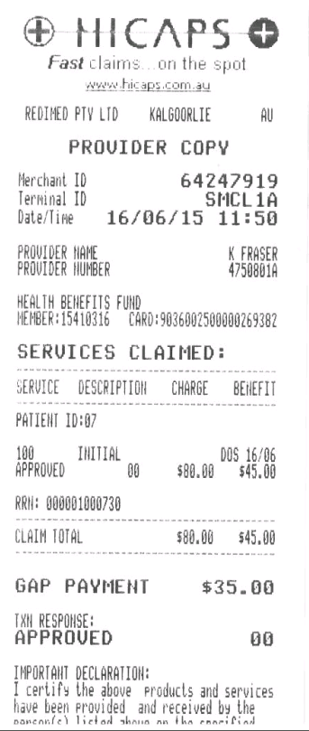Once the rebate has been processed through the HICAPS machine it will print a receipt with how much the health fund has covered of the appointment.

The remaining amount will display as GAP Payment. This is the amount the patient has to pay

1. Process the GAP payment through the HICAPS machine.
2. Invoice this amount off the Invoice on Genie as you would an eftpos receipt  
   In this instance the health fund has covered $45.

We have to receipt the HICAPS amount off first

1. 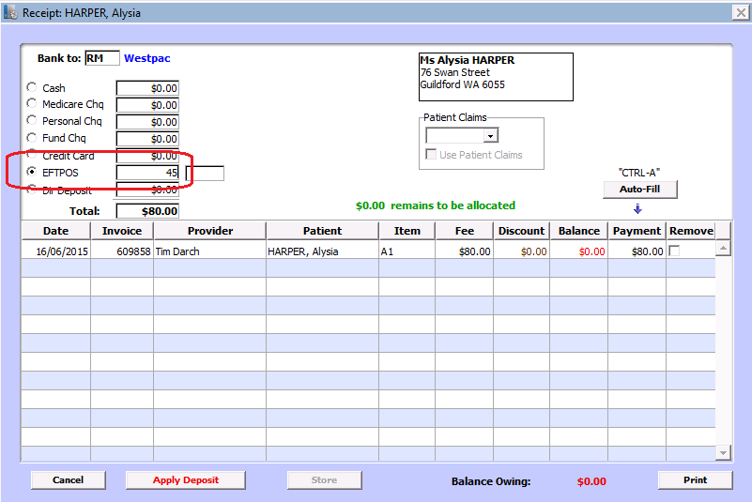Change the Eftpos amount to the amount HICAPS have covered ($45)
2. Enter in the box the RN number – all the numbers after the first lot of zeros

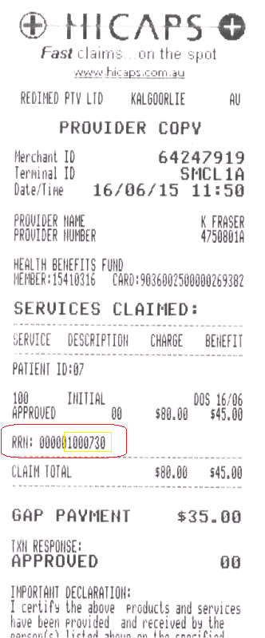

In this instance we would enter in 1000730 into the box

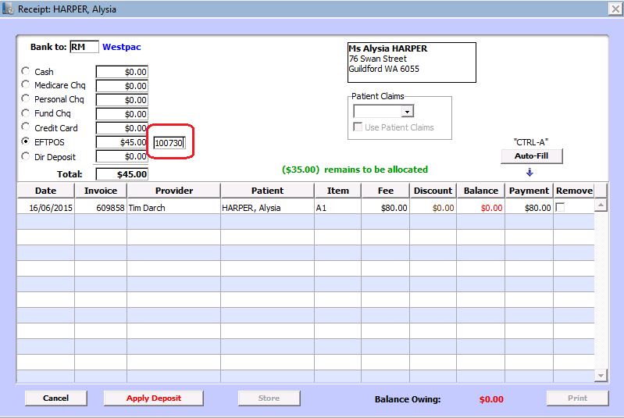

1. Click Autofill
2. Click Cancel – This will take you back to the payment screen so we can invoice off the remaining amount for the FAP payment.
3. Repeat the process to invoice off the GAP amount

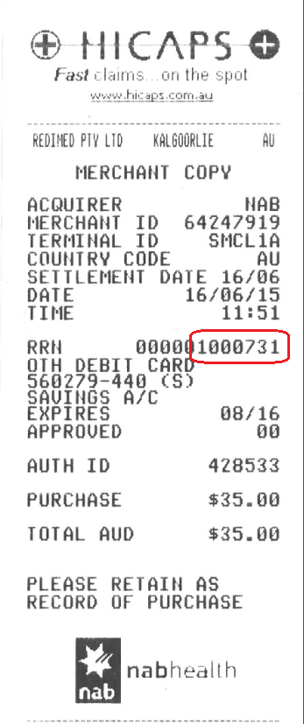Enter in the RN number from the GAP payment receipt into the box

1. Click PRINT to print the invoice to give to the patient
2. **Processing a Payment Using HICAPS and charging the REBATE**

This process is used for Redimed staff appointments with physiotherapy or Hand Therapy, family and partners of Redimed staff members and associated sports club patients.

There is no out of pocket costs for this consult - we only charge what we receive from the Private Health Fund.

1. Go to the physio/hand therapy appointment on Genie
2. while that appointment is selected, click on the dollar sign to invoice the consult
3. Click ‘Add Item to Invoice’
4. Enter in the consult code – In this instance we are invoicing an initial consult for a hand therapy consult – a1 for a staff member
5. Now Swipe the health fund card in the HICAPS machine and follow the process





1. Once the rebate has been processed through the HICAPS machine it will print a receipt with how much the health fund has covered of the appointment.  
     
   The remaining amount will display as GAP Payment. This is usually the amount the patient is out of pocket, but in this case we don’t charge the GAP.
2. Click CANCEL to cancel the GAP payment.
3. Go back to the add Item to invoice screen and change the payment amount to the amount the Health Fund has covered. In this case $45.00 and enter into the notes why the consult has been discounted:-
   1. Staff member consult
   2. 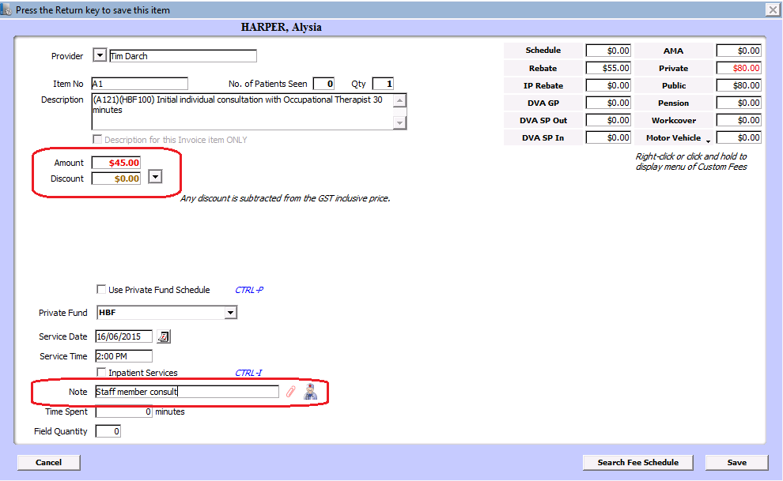Family member consult

Please Note: Make sure you change the amount in the box highlighted below and not the box to the right (circled in red) as this will change the amount each time you invoice that code to a patient.

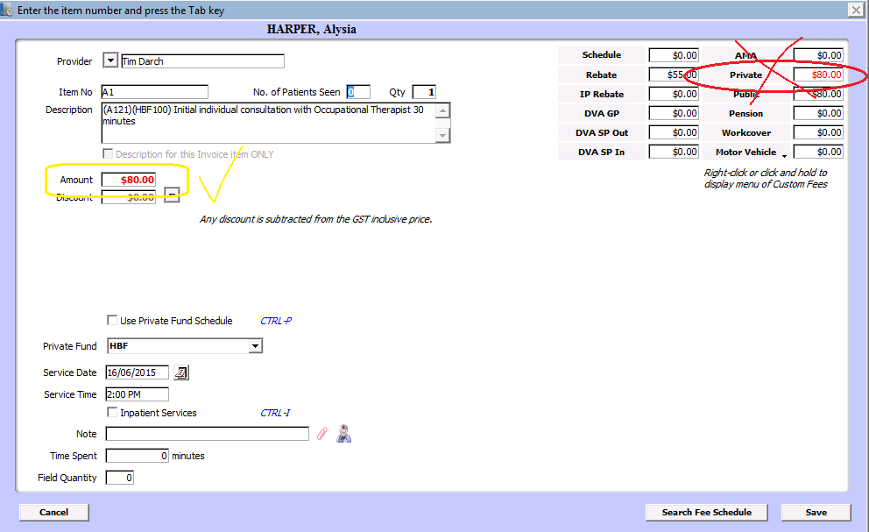

1. Click Save and this will change the invoice to the rebate amount
2. Follow the Normal Payment process to receipt off the invoice.

**Missed Billing**

At the End of each day one person from reception is to go through the clinic lists to see if any private/public patients haven’t been billed for the day

1. At the end of each day, the lists for the day will need to be checked, and a list of any private or public patients is to be made
2. The list of missed billing is to be emailed to Wendy Brooks (wbrooks@redimed.com.au) directly at the End of each day
3. INVOICE THE MISSED BILLING PATIENTS – Create the invoice with (no need to post invoice, Wendy will do this – see next step)
4. Once the invoice is created and you have sent the list to Wendy, she will post the invoice to the patients with a 14-day notice of demand to pay and add in the appropriate memos and notes in the appointment screen as a reminder to collect payment when they come in.
5. Whoever is checking a patient in needs to be mindful of these payment notes and any prompts with $ signs that come up. THIS MEANS THE PATIENT HAS AN OUTSTANDING ACCOUNT. You can check them in as normal, and advise them they have an outstanding account to pay TODAY!!! It is important to remind them before it gets to the debt collecting stage, just be polite, and where possible direct them to the payment desk, or you can assist them with the payment also.

# Appendices